*“*Food for friends*”*:

New way for people get friends through social net work application and food

**THESIS**

**Submitted in Partial Fulfillment of**

**the Requirements for**

**the Degree of**

MASTER OF SCIENCE (Integrated Digital Media)

at the

NEW YORK UNIVERSITY

TANDON SCHOOL OF ENGINEERING

By

Tianyu Ren

Spring 2016

## 

*“*Food for Friends*”*:

New way for people get friends through social net work application and food

**THESIS**

**Submitted in Partial Fulfillment of**

**the Requirements for**

**the Degree of**

MASTER OF SCIENCE (Integrated Digital Media)

at the

NEW YORK UNIVERSITY

TANDON SCHOOL OF ENGINEERING

By

Tianyu Ren

Spring 2016

Approved:

Adviser Signature

Date

Department Head Signature

Date

Copy No.

University ID#:

# Approved by the Guidance Committee:

Integrated Digital Media

Brian MacMillan, Project Advisor

Integrated Digital Media

NYU Polytechnic School of Engineering

Date

DeAngela Duff, Co-Director

Integrated Digital Media

NYU Polytechnic School of Engineering

Date

Karl Hohn, External Reviewer

Software Application Developer

Date

# Vita

## ABSTRACT

*“*Food for friends*”*:

A new way for people get friends through social net work application and food

**by**

**Tianyu Ren**

**Advisor: Prof. Brian MacMillan, MS**

**Submitted in Partial Fulfillment of the Requirements for**

**the Degree of Master of Science (Integrated Digital Media)**

**May 2016**

**Food For Friends** is an application help people who is new in a new place or travelers to have new friends. At the same time, through this application people could get reasonable price food and have an unforgettable travel experience and memory in their life time. By this platform, users could have different experiences between other travel or food guide applications or any other social network applications. People could get face to face connection with other people.

Keywords: food, friends, application, new travel experience, social network

# Table of Contents

Approved i

Approved by the Guidance Committee: ii

Vita iv

ABSTRACT v

Table of Contents vi

List of Figures vii

Background 1

Introduction 1

Research 1

Statement of Purpose 2

Background 2

Target and Audience 3

Research Overview 3

Methods and Techniques 4

Technology Overview 4

Visual: 4

Design 4

Visual: Augmented Reality 10

Development 10

Market 10

Outcomes and Conclusions 11

What Worked 11

What Did Not Work 11

Options For Expansion 11

Conclusions 11

Bibliography 12

# List of Figures

**Figure 2**: home page 5

**Figure 3**: recommend page 5

**Figure 4**: restaurant information page 6

**Figure 5**: City page 6

**Figure 6**: Restaurant page 7

**Figure 7**: personal information page 7

**Figure 8**: message page 8

**Figure 9**: food story page 8

**Figure 10**: food story page 2 9

**Figure 11**: favorite page 9

**Figure 12**: create group page 10

# Background

## Introduction

**By using “Food For Friends”, people who is new in a strange place or tourists are able to know new people and get new friends when they are having delicious food.** There are already a few info-share mobile applications or webs trying to provide useful travel information for travelers. However, they ignored the importance of the connection between people, and people in these kind of platform just could face to the words that people written, and they also didn’t have an important point in their working. People who using these application and webs always could not really get useful information and make their user experience bad. To give a better user experience for people and help people get friends when they are in a new place, “Food For Friends” is made to improve their experience and help more people in their trip. “Food For Friends” is a web based information-shared mobile application specific for travelers and people in new place without friends and feeling lonely, which aims to be the best trip-guide for travelers and a good social network platform through combine information gather, technology and UI design.

## Research

There are some similar features apps in the app store right now. So what is the different of “Food For Friends” with them?

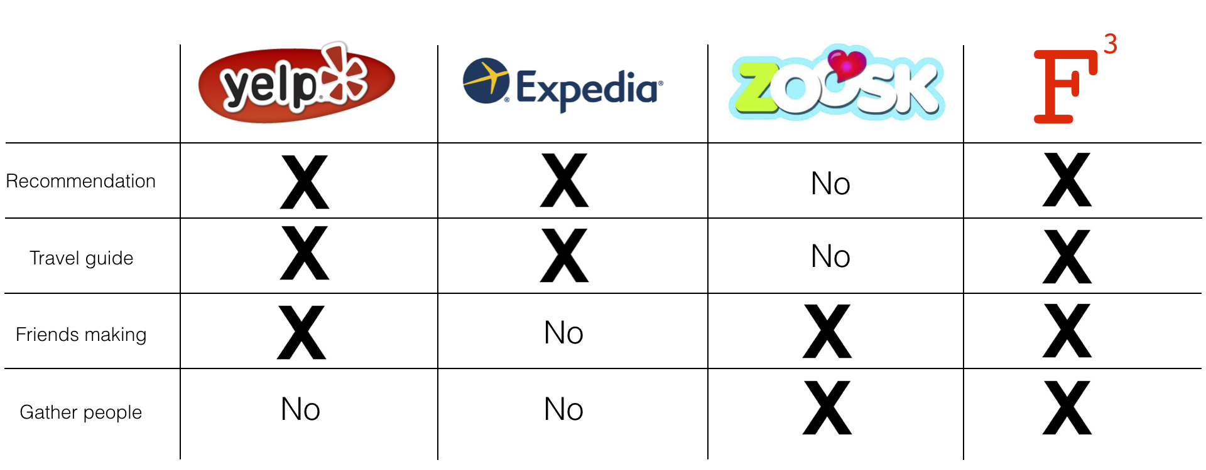

The main idea of the “Food for friends” is about four functions for users: recommendation, travel guide, friends making and gather people.

## Statement of Purpose

There are lots of social network mobile applications in the market and there are also many food rate platforms now too. The market of the restaurant and the social network users is growing so fast, lots of new methods are coming out every day. When people make friend with others by application, actually they are using their personality things to build connection with others, such as habit and interest. I pick the one of the most important and specific concept from people’s interest and use it to build a new way to help people connect with each other and have fun.

## Background

With the Globalization development increasing rapidly, the people from different culture and different country are fixing a lot. As in NYC, millions people are living over here, there are so many different cultures. However, I think this advantage was not good use. Humans are curious about different culture but most of them don’t have opportunities to get a different culture friend. And also there are many new people come to a new place every day. How to help them go inside to the new culture(new environment) is also a big problem.

## Target and Audience

“Food For Friends” focuses on travelers and people who come to a strange place and want to have some friends. At the same time, “Food For Friends” also want to help people have nice and delicious food with a reasonable price with a friendly and unforgettable experience and memory. It could also be a useful food guide all over the world for foodie and everyone could have fun by it.

## Research Overview

Brain storm Mind map.

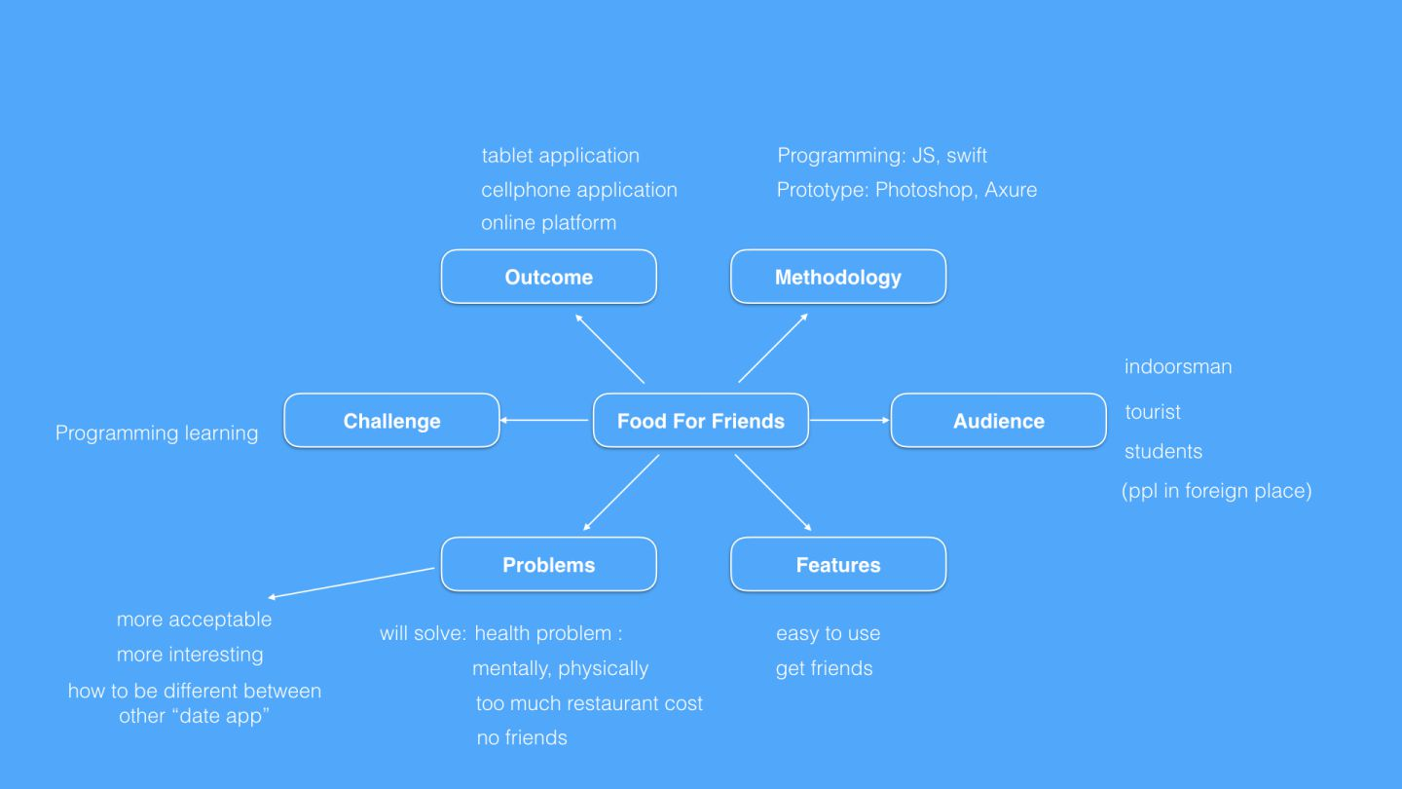

# Methods and Techniques

## Technology Overview

## Visual:

## Design

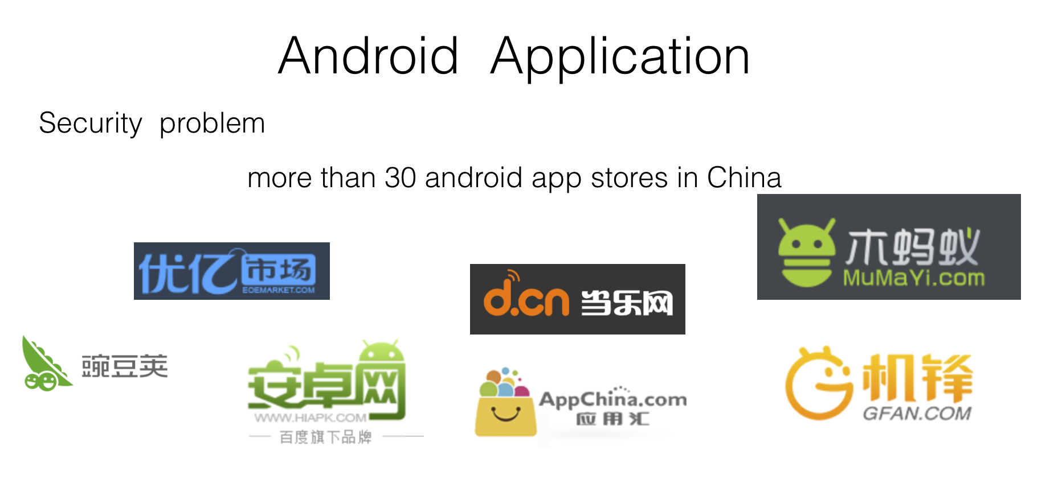

Food for Friends is an application only for iOS system. iOS system is much safer than Android system although Android system have much more market than iOS system. In China, there are more than 30 Android app stores, and most of them are not such formal as Google app store. There are so many hacker apps in these store and it should be a big Security risk for user’s personal information. Therefore, because of there will be a lot of personal data on the “Food For Friends”, iOS app store should be the best platform for it.

UI design as seen in **Figure 1**



1.

2.

3.

4.

5.

**Figure 1**: home page

[**Figure 2**].

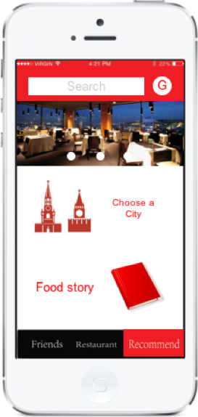

1.

2.

3.

4.

5.

**Figure 2**: recommend page

[**Figure 3**].

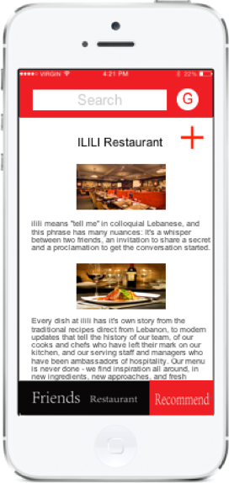

**Figure 3**: restaurant information page

[**Figure 4**].

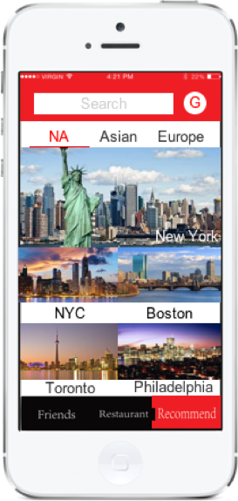

**Figure 4**: City page

[**Figure 5**].

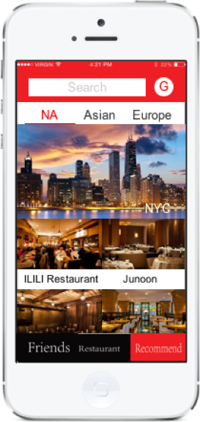

**Figure 5**: Restaurant page

[**Figure 6**].



**Figure 6**: personal information page

[**Figure 7**].



**Figure 7**: message page

[**Figure 8**].



**Figure 8**: food story page

[**Figure 9**].



**Figure 9**: food story page 2

[**Figure 10**].



**Figure 10**: favorite page

[**Figure 11**].



**Figure 11**: create group page

## 

## Development

Data base :

DBMS: Oracle

C++

Front end: HTML & CSS.js

Adobe Dreamweaver

Middleware: java

## Market

At the beginning of this app marketing, I just want to try it in Chinese. At the same time, it’s would be comfortable for people using their Weibo and Wechat account to login this application, it would be

From my research, I find that Chinese are more comfortable on sharing food with other people during the dinner. It’s because of culture.

Date app problem………………..

# Outcomes and Conclusions

## What Worked

## What Did Not Work

## Options For Expansion

## Conclusions

# vite